MVR Check Process – Single Employee Upload

Any charges/fees associated with running a Motor Vehicle Record (MVR) is the responsibility of the employing department and will be billed monthly by Transportation Services. The charges vary by State; however, departments should prepare for the average fee of $5.50 per record check.

Navigate to First Advantage
https://enterprise.fadv.com/

Sign in with ClientID 233291,
Your UserID, and Password
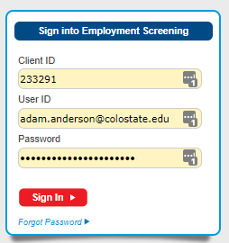

Agree to the notice that is displayed
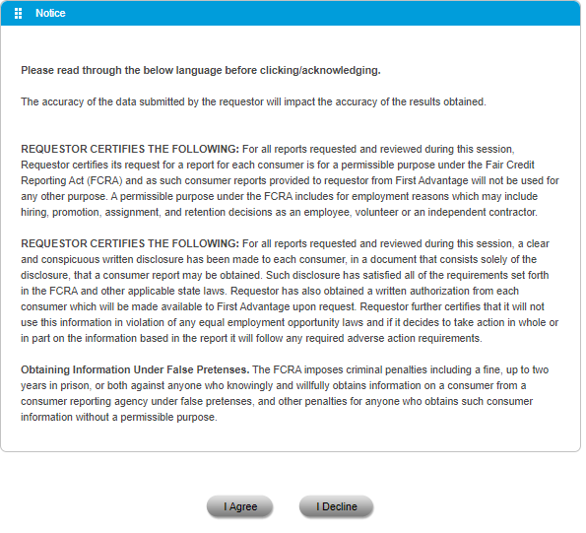

On the left hand pane click on Employment Screening to expand that menu, then New Order

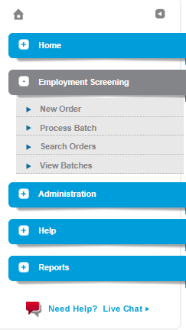

The first page you will see is a tab labeled ORDER.
Here the section labeled Requestor Information should auto populate your data.
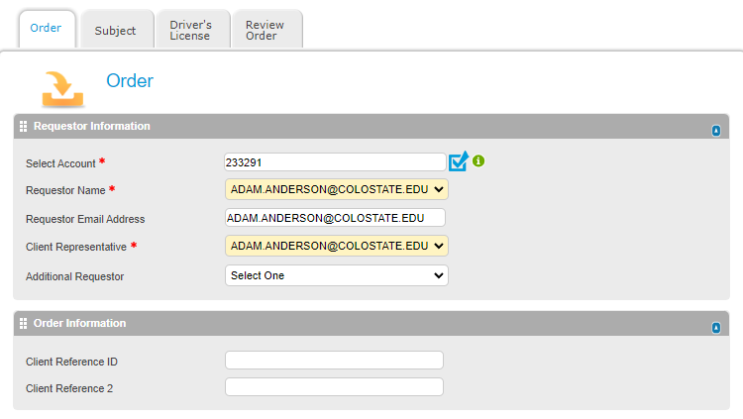

Scroll down and click the drop down menu for COUNTRY and select United States. Enter FORT COLLINS in the space for City/Municipality. Now click the drop down menu for STATE/REGION and select Colorado.
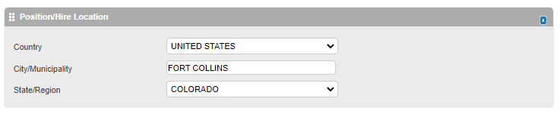

Under the section labeled Package Selections click the drop down labeled CUSTOM PACKAGE and select Mvrs.
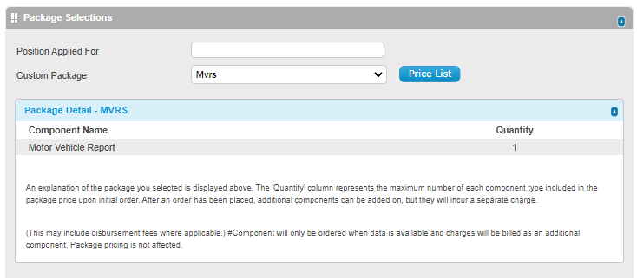

At the very bottom of the page click the NEXT button.

The tab labeled SUBJECT will now open. Here you need to enter the information of the person for which we want to have the MVR check completed. All fields marked with a RED asterisk are required. *It is also highly recommended to enter the Birth Date as well for accuracy and speed of results*.
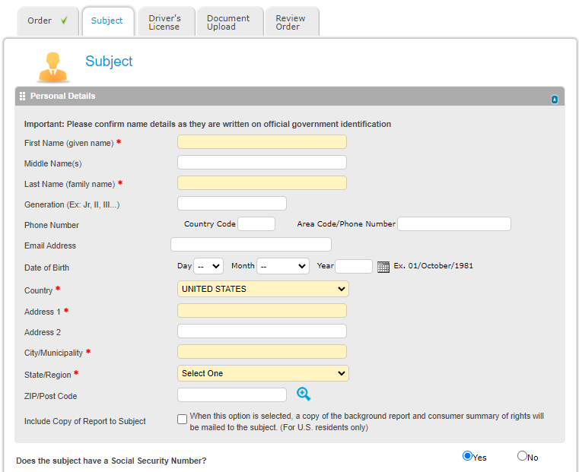

Change the radio button to NO for the Social Security Number

Scroll to the bottom of the page and click the NEXT button

This next tab is for the Driver’s License information. Here you need to fill out all the fields displayed. The license type should be NON-COMMERCIAL.
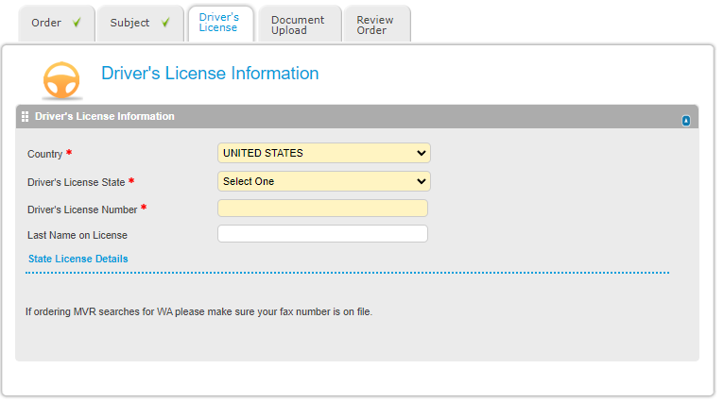

Once filled out click NEXT at the bottom

The next screen is for uploading documents. On this page we simply click the NEXT button at the bottom of the screen.

The last page is for reviewing the information entered for the MVR. Here you can check the accuracy of the information that was entered on the previous screens by click on the + icons.
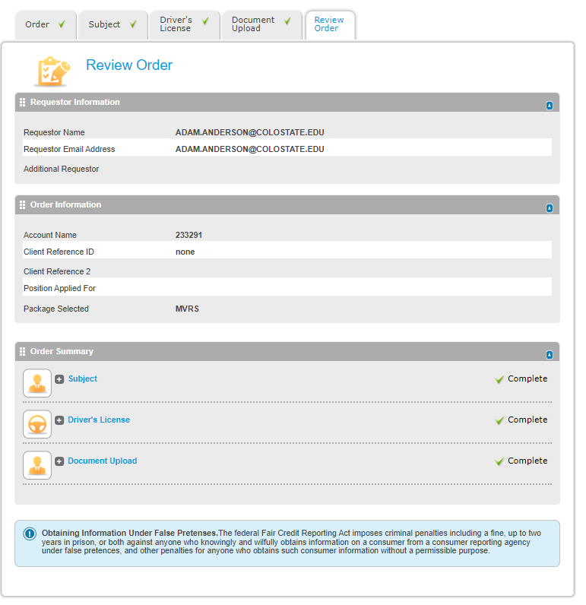

The last step is to click the SUBMIT button at the bottom of the page.

After clicking the SUBMIT button you should see a window appear confirming that the MVR has been successfully submitted.
