ERL Buildings and Lots
- Clients
  - Entering east drive way off Rampart
  - Trailers will either pull up to gate on east side and get permission to enter gates or pull through east entrance (Gate 3) and up to west gate (Gate 2) in front of ERL building, gain permission and then pull around southwest side, driving around south side buildings to exit west side driveway
  - The circle parking area north of building, along Rampart Rd has state vehicle spaces and client only spaces
  - Parking west of dog and pig area (smaller building, L-shaped, on south east side)
  - If there is client parking only on site, similar a designated area at VTH, this specific area would be maintained, to main campus standards, by the department. Parking and Transportation Services could be contracted out to provide this maintenance.
  - Client trailers park in field/grass area that is southwest of the stallion barn when they need to be there all day. Allowing them to leave ERL site during the day without hauling the trailer around town. Occasionally, there is long term trailer parking.
- There should be no one parking south of central mare barn with exception of state vehicles and clients that are pulling through to drop off/pick up and exit the west driveway.
- West side entrance of ERL is not gated during daytime working hours 5 AM – 9 PM. This allows for feed truck access, and deliveries such as propane, shavings, Fed Ex, other bulk deliveries. A manual gate, this gate is not electric. Feed crew are usually on site at 5 am, leaving in afternoon.
- Employees are arriving as early as 5am and some are staying in Intern Apartment on site, currently 2 Interns, possibility of adding a third. Two vehicles are on site 24 hours/overnight parking.
- Students and grad students
  - allowed to park on northeast lot, north of gate 3 or adjacent to stallion turnout paddox
  - sometimes use Pickett Equine Center parking lot (north side) and walk along road up to ERL
  - park on north side of Rampart Rd near hay sheds for short term parking
  - park east of ERL building near the east driveway entrance, north of the gate
- Faculty/staff park on east side of ERL bldg, entering east driveway and just south of the gate(Gate 3)
- Currently due to classes at ERL vehicles park on north side of Rampart Rd, impacting visibility. Moving parking off the roadside to open field indicated in map below would provide overflow parking up to 30-40 vehicles. Vehicles in overflow future lot should be 3-4‘ from bumper to barn.
- Three to four classes with 30-40 students and sometimes guest attending classes.
- Main ERL site is used for animal movement
- ERL does their own snow plowing and would request that areas identified as sensitive would continue to be plowed by current service
- There needs to be access to the haybarn from the east side. Also possible falling hay, when the stacks get low.
- Staff walk horses across Rampart Rd – Possible addition of a crosswalk for both pedestrian and horse traffic. Mornings are busiest.
- Pavement isn’t good for walking horses due to slippage
- Paved parking areas should not give the public greater accessibility to horses. Horses can be spooked and parking close to horses may encourage individuals to disturb horses, trying to pet them. In addition, we should consider the distance required to quarantine horses from the public.
- Faculty/staff/student parking areas managed and maintained by Parking and Transportation Services
- Estimated 40 employees (15-20 usually on site at all times with flex up for seasonal support).

Alternative Parking and Transportation
- Parking and Transportation Services investing in design plan and advocating for connector road to support a campus shuttle (Connector road referenced is the road off Laporte, used to access Atmospheric Science turnoff and exits onto Rampart in front of ARBL)
  - Connector road to include bike and pedestrian path
  - Poudre Fire Authority support due to safety issues with dead end roads
- Consider alternative shuttle options, on demand, 15/20 min service, size of shuttle (van option)
- Evaluating transit turn/drop off area at B.W. Picket Equine Center. Four routes currently go by the Equine Center so area may offer opportunity for transit turn around.
- Need for year round transit options (summer routes)
- Evaluate remote parking option near Transit hub

Deliveries
- This area needs further discussion – for other pick up/deliveries occurring on site other than movement of horses captured above under client parking.
- FexEx delivery daily.
- Campus mail delivers to main building

Other Items
- Lighting could be improved on the east side of ERL building. Lighting is not an issue for horses as impact is positive related to reproduction. Lights can be installed in future overflow parking lot.
- Further discussion needed regarding operations at ERL site and buffalo reproduction area near west campus road (lighting and traffic impact on operations)
- Careful consideration for horses and impact to traffic flow
- Flashing lights at pedestrian crosswalks across Rampart, in front of main ERL building, would be a good addition to slow down traffic.
- Large semi truck moves through west side for bedding Annex and movement for feed trucks

Parking Lot Construction & Permitting
- Permit cost < Main Campus, offer multiple permit options, include options similar to main campus.
  - Consider Foothills only permit to lower cost and remote option (B.W. Pickett Equine Center)
  - Consider current Moby permit to allow parking at Foothills and at Moby lot on main campus
- Permitting online, consider centralized pay station location(s)
- Enforcement would be same hours as main campus
- If individuals already have a permit for main campus that permit would be good for Foothills with the exception, of apartment housing permits. Apartment housing permits are provided by Housing specifically for the apartment parking lot only as part of the individuals residence.

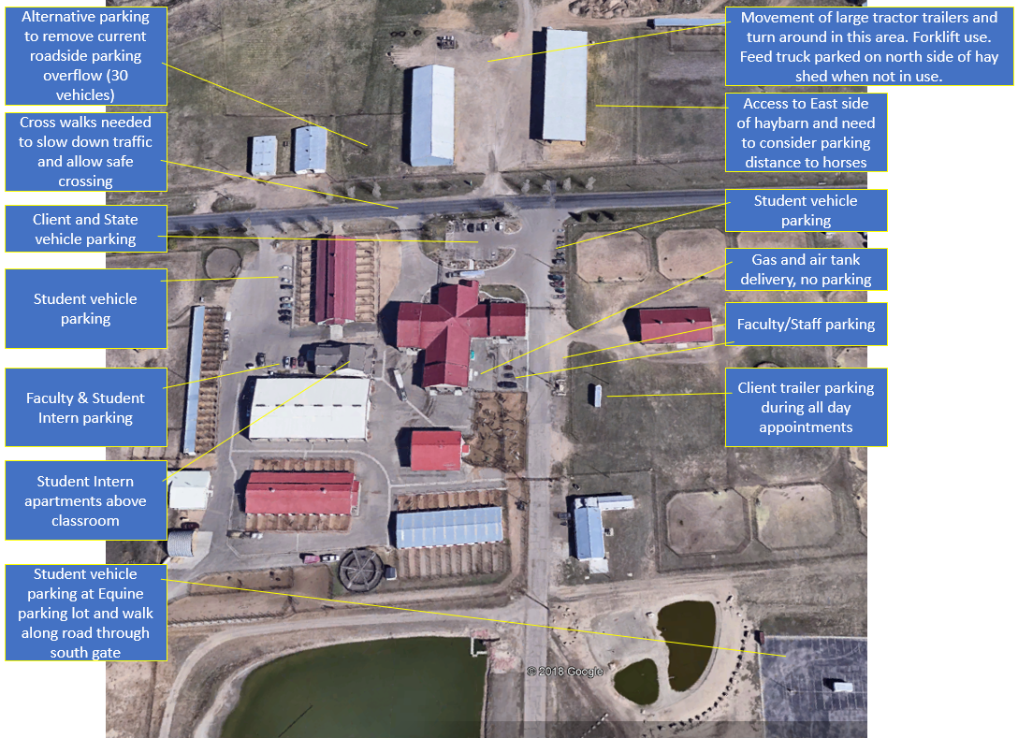

North side of Rampart Rd, east of hay sheds.
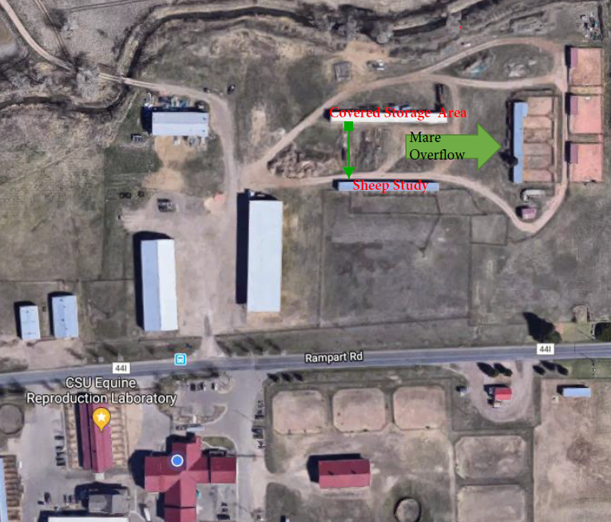
Generally does not have much traffic. The primary uses are ETRC colt quarantine, Harmony Equine Quarantine, ERL Mare overflow. Occasional overnight stalling for a client, on as-needed and special occasion use only. Long white shed, is covered storage, far east pens are ETRC, barn marked sheep study, has had sheep in the past. No further details on type of sheep studies, but possible lighting on a parking area south of fisheries building might have a negative effect on any reproductive studies over there.

