ARBL & ADL Buildings and Lots
- When there are classes at ARBL the west side parking lot is fully utilized
- Faculty and students park in lot west of ARBL. Lot also used when weather creates difficulty in accessing north entry door.
- Individuals using the east and north lot utilize parking in those areas interchangeably.
- Classes held every day or 2 to 3 times/wk depending on semester, with 30+ additional vehicles in lot
- Lot needs lines and signage to improve parking management/organization
- Parking spaces need to consider majority truck usage (pick up trucks)
- ADA access at main door and west side door but no designated parking. Incline on north and west side is an issue regarding accessibility for ADA.
- Vehicle traffic due to animals on site should be restricted to front side of buildings with the exception state vehicles and the west ARBL parking lot.
- Two electric vehicles are parking on site currently
- Currently no defined parking areas on site
- Two or more motorcycle parking spaces to accommodate individuals currently riding
- Designated area for visitors needed
- 20-minute loading areas are needed
- Northside of ADL is unloading area for animals
Alternative Parking and Transportation
- Parking and Transportation Services investing in design plan. Advocating for connector road to support campus shuttle (Connector road referenced is road off Laporte, used to access Atmospheric Science turnoff & exits onto Rampart). Current funding for design only, road still pending funding.
  - Connector road to include bike and pedestrian path
  - Poudre Fire Authority support due to safety issues with dead end roads
- Consider alternative shuttle options, on demand, 15/20 min service, size of shuttle (van option)
- Consider campus bus from Pickett Equine Center to Lake Street Garage east turn around area, accommodating a centralized drop point at main campus rather than a north transit stop at LSC, potentially reducing the number of vehicles driving to class at ARBL
- Evaluating transit turn/drop off area at B.W. Picket Equine Center. Four routes currently go by the Equine Center so area may offer opportunity for transit turn around.
- Need for year round transit options (summer routes) and during semester breaks
- Evaluate remote parking option near Transit hub
Deliveries
- Liquid nitrogen deliver is to the south east side of ARBL. Large truck access needed
- Semi-truck and stock trailer (30-40’) access north and south side of ADL. Animals south side of ADL need feed truck access behind monkey house
Other Items
- Lighting in ARBL parking lot is not an issue but if lighting improved in lot it won’t be an issue. The concern for lighting is along the new connector road and how this lighting can be managed to not impact sheep or other animals
- Bison and Sheep that are on north side of Rampart Rd prefer no light
- Lighting improvement ARBL west parking lot won’t interfere with Sheep on north side of Rampart Rd.
- Bison shift to north facility is delayed due to funding, Jennifer Barfield is working on submission for project to move to north facility. FM, PTS and ARBL will work to align projects, sensitive to timelines and funding, evaluating the shift of timelines and our funding sources (bridge funding) to ensure accommodations to ARBL operational needs. North facility is owned by CVMBS
- Project plan development meeting to move Bison from current facility to north facility schedule for end of March. Team will be reviewing fence and pen needs for north facility location, both horse and bison containment.
- Jennifer will provide a dollar figure regarding Bison project by early April.
- Current requirement for animal quarantine will end Q1 2020.
- Concern with increased traffic that new road might welcome and how to separate people/vehicle/bike interaction and accessibility to animals.
- Need to consider how to keep people from accessing/interfering with animals, specifically after Bison move to north facility, how can we create barrier from new road to sheep facilities and barrier to future animals (elk or swine) that might be held at the current Bison facilities
- Large equipment needed for hauling hay
- Students travel to site between classes held on main campus and have tight travel timelines requiring that they drive vehicles currently
- Seminars are sometimes held on site after 4 PM
- Consider plowing services prior to work schedule to reduce traffic on site and allow safe clear access for staff arriving before 7 AM
Parking Lot Construction & Permitting
- Permit cost < Main Campus, offer multiple permit options, include options similar to main campus.
  - Consider Foothills only permit to lower cost and remote option (B.W. Pickett Equine Center)
  - Consider current Moby permit to allow parking at Foothills and at Moby lot on main campus
- Permitting online, consider centralized pay station location(s)
- Enforcement would be same hours as main campus, 7:30 AM to 4 PM
- If individuals already have a permit for main campus that permit would be good for Foothills with the exception, of apartment housing permits. Apartment housing permits are provided by Housing specifically for the apartment parking lot as part of the individuals residence.
- Permit and enforcement forecasted to start summer 2020
- One permit for Foothills campus to accommodate movement of individuals between buildings
- Departments can purchase permits for guests similar to department practices today on main campus
- Large equipment does not require permit
- State vehicles require permit
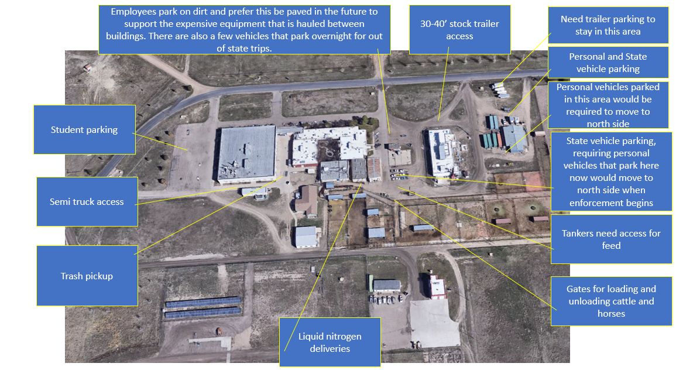
- Other options may be available to seminar attendees to provide hangtags, a code for a pay station or other virtual options to support guest parking

