MVR Check Process – Batch Employee Upload

A template for the MVR upload can be located on the Parking and Transportation Services webpage under “Documents of Interest”. https://pts.colostate.edu/transportation/
The first spreadsheet tab has instruction on how to fill out the template for batch processing. The second spreadsheet tab is where you will enter the driver information. The field for CR1 should be the department initials (I.E. PTS – Parking Services, FAC – Facilities, HDS – Housing and Dining). Fields listed in RED are required, and a “N” should be entered in the field for “Has SSN”. Any Drivers license number that starts with a zero needs to have an apostrophe at the beginning (I.E. ‘003589478). Save this completed spreadsheet in an accessible location.
Any charges/fees associated with running a Motor Vehicle Record (MVR) is the responsibility of the employing department and will be billed monthly by Transportation Services. The charges vary by State; however, departments should prepare for the average fee of $5.50 per record check.

Once the spreadsheet is ready, open a browser and navigate to https://enterprise.fadv.com/
Sign in with ClientID 233291,
Your UserID, and Password
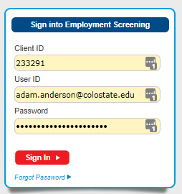

Agree to the notice that is displayed
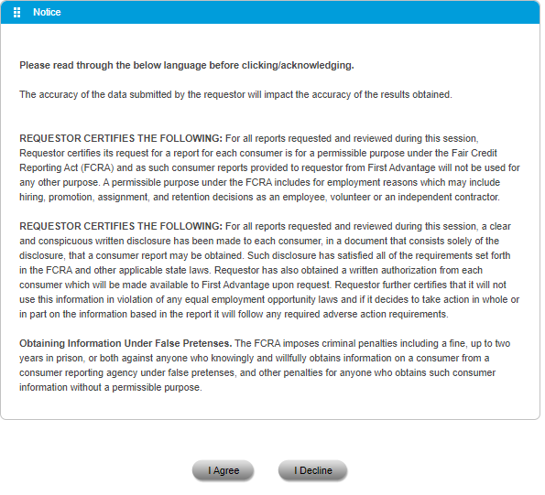

Once you are logged into the First Advantage system you should see a navigation menu on the left hand side of the screen. Expand the selection for “Employment Screening” by clicking on the + symbol
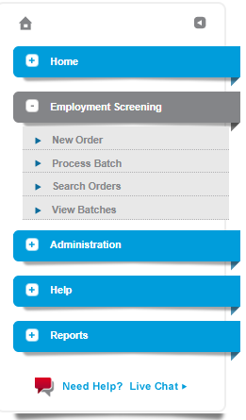
Click on the option to Process Batch. A new webpage opens for batch processing. The top section labeled “Requestor Information” should auto populate with your data as shown in the picture below.
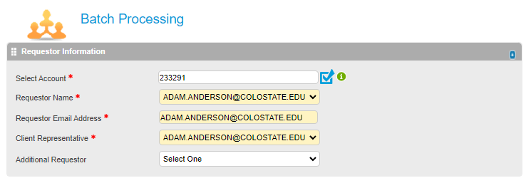

On the section labeled Package Selections, click the Custom Package dropdown menu and select “Mvrs”.
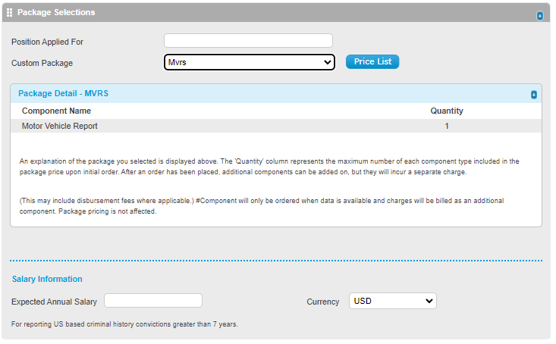

On this Batch Processing webpage you want to navigate to the bottom section labeled “Batch Upload”. Here is where you can upload the batch processing spreadsheet.
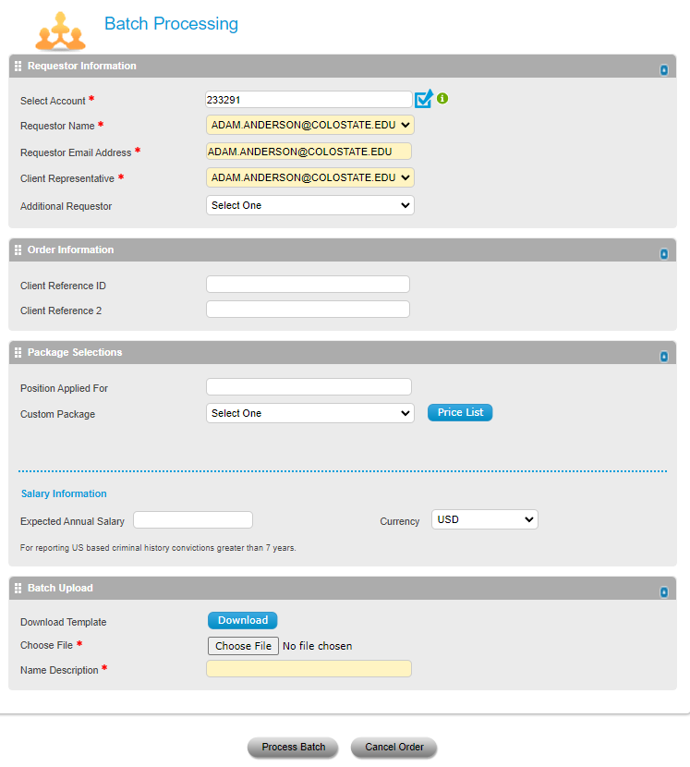
Click the button to Choose File and a new pop-up window will open. In this new window you want to navigate to the motor vehicle record spreadsheet you want to upload. Select the spreadsheet and click OPEN.
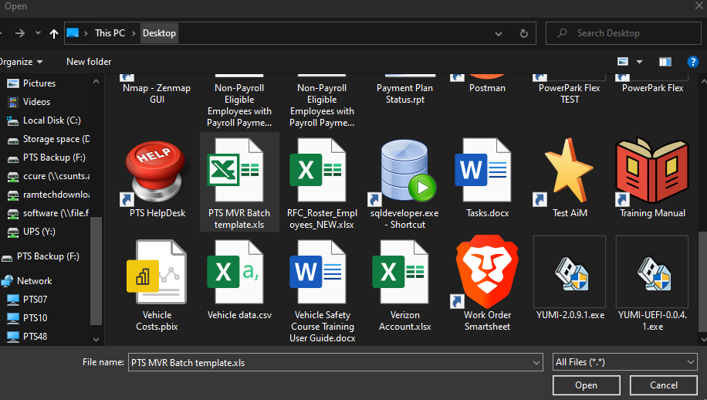
You should now see the name of the file you want to upload listed to the right of the Choose File button that was selected on the previous step.
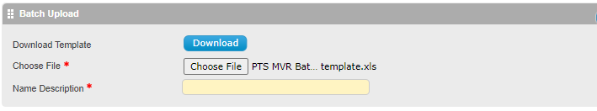
Add any description you would like as a reference in the Name Description box. Then click the Process Batch button at the bottom of the webpage.
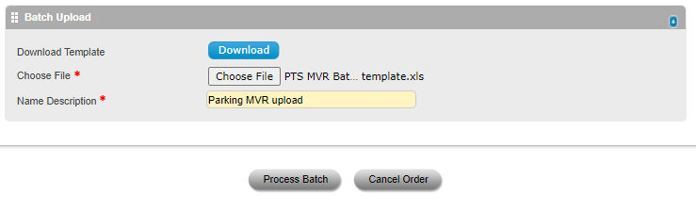
A new webpage will open displaying the batch as well as the status.
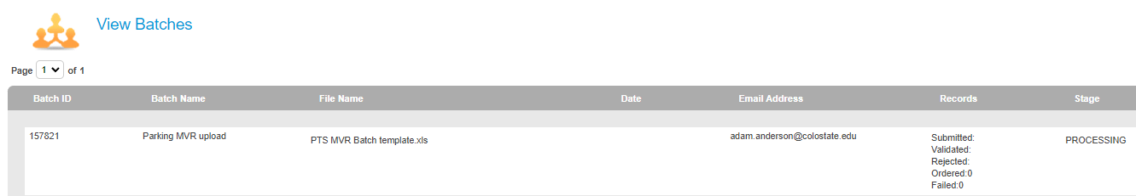

Congratulations! The process is now complete. You should get an email with notification of the submitted batch status should an error occur.

